Skye LeForge

FEBRUARY 18, 2018  CSC 340, Department of Computer Science, EKU

Individual Project: Pizza Ordering System

Design Specification Report

Contents

I. Introduction 2

A. Problem Statement 2

B. Proposal 2

II. System Description 2

III. System Requirements 2

A. Functional Requirements 2

B. Non-Functional Requirements 2

IV. Use Case Diagram 2

V. Class Diagram 2

VI. Sequence Diagram 2

VII. State Diagram 2

VIII. Activity Diagram 2

IX. Database Diagram 2

A. ER Schema 2

B. Table Schema 2

# Introduction

## Problem Statement

## Proposal

# System Description

# System Requirements

## Functional Requirements

## Non-Functional Requirements

# Use Case Diagram

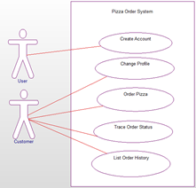

# Class Diagram

# Sequence Diagram

# State Diagram

# Activity Diagram

# Database Diagram

## ER Schema

## Table Schema